PFC CONSULTING LIMITED
(A Wholly Owned Subsidiary of Power Finance Corporation Ltd.–
A Government of India Undertaking)

Electronic Tender Document

For

Appointment of Implementing Agency for Distribution Sector Information Aggregation & Analytics Portal


Registered Office:
1st Floor, “Urjanidhi”
1, Barakhambha Lane, Connaught Place,
New Delhi - 110001

Corporation Office:
9th Floor, A Wing
Statesman House, Connaught Place,
New Delhi - 110001

April 30, 2021

E-Tender Notice No.: PFCCL/2020-21/IA/AAP April 30, 2021
PFC Consulting Ltd. invites E-Tenders for - Appointment of Implementing Agency for Distribution Sector Information Aggregation & Analytics Portal.
Important Dates and EMD
 | Start Bid Date & Time | April 30, 2021 from 18:00 hrs (IST)
 | Close Bid Date & Time | May 15, 2021 till 15:00 hrs (IST)
 | TOE Start Time | May 15 , 2021 at 15:30 hrs (IST)
 | Financial Bid Opening | To be intimated to qualified bidders
Note:
- Tender Notice and Tender Document are available on PFC Consulting Ltd. website and can be downloaded from https://www.pfcclindia.com. For bid submission, the Bidder will have to necessarily download an official online copy of the Tender Document from e-Procurement Portal http://www.mstcecommerce.com/eprochome/pfccl/buyer_login.jsp. All future Information viz. corrigendum /addendum/ amendments etc. for this Tender shall be posted on the PFC Consulting Ltd. website and said e-Procurement Portal only. Printed copy of Tender Document will not be sold from PFC Consulting Ltd. office.
- The bidder shall bear all costs associated with the preparation, submission/participation in the bid. Purchaser in no way will be responsible or liable for these costs regardless of the conduct or outcome of the bidding process.
- Bidders are advised to start the registration process on the e-Procurement Portal as it may take a few days so as to avoid any delay in bid submission (upload) stage. Bidders may visit MSTC’s e-procurement Portal Guidelines for vendors at https://www.mstcecommerce.com/eprochome/UserManualVendor.pdf for further details.

TABLE OF CONTENTS

S. No. | Description | Page No.
 | Section-1: Bid Invitation Letter | 5
1.0 | Scope of Work | 6
2.0 | Deliverables | 10
3.0 | Eligibility Criteria | 10
4.0 | Period of Engagement | 12
5.0 | Basis of Offer | 12
6.0 | Team Composition and Team Members | 12
7.0 | Submission of Bid | 12
8.0 | Bid Opening and Evaluation of Proposals | 14
9.0 | Contract Performance Guarantee (CPG) | 16
10.0 | Office at Delhi / NCR | 17
11.0 | Contract Agreement | 17
12.0 | Validity of Bid | 17
13.0 | Terms of Payment | 17
14.0 | Travel Expenses | 18
15.0 | Other Terms & Conditions | 18
 | Section-2: Bid Forms and Proforma | 20
 | FORM-1: COVERING LETTER | 21
 | FORM-2: EXPERIENCE OF ORGANISATION | 24
 | FORM-3: COMPOSITION OF TEAM AND THE TEAM LEADER TO BE DEPLOYED | 26
 | FORM-4: CURRICULUM VITAE FOR EACH MEMBER OF Consultant’s TEAM | 27
 | FORM-5: AUTHORISATION LETTER | 28
 | FORM-6: SCHEDULE OF PRICE BID | 29
 | FORM-7 : THE PROPOSED METHODOLOGY AND WORK PLAN | 30
 | FORM-8: UNDERTAKING | 31
 | FORM-9: PROFORMA FOR BANK GUARANTEE FOR CONTRACT PERFORMANCE | 32
 | FORM-10: CONTRACT AGREEMENT | 34
 | SPECIAL INSTRUCTION TO BIDDERS FOR  E-TENDERING | 47

SECTION -1
BID INVITATION LETTER

BID INVITATION LETTER

Ref: PFCCL/2020-21/IA/AAP April 30, 2021
To
……………………….
……………………….
……………………….
Sub: Electronic Bids are invited for Appointment of Implementing Agency for Distribution Sector Information Aggregation & Analytics Portal
Dear Sir,
PFC Consulting Limited (PFCCL) wishes to avail services of a firm for Distribution Sector Information Aggregation & Analytics Portal.
Electronic Bids for the above are invited in single stage two envelope system (Technical bid & Price bid) from Indian firms/organizations.
The Scope of Work, Deliverables, Eligibility Criteria, Selection Procedure and Criteria, Terms of Payment, Terms and Conditions etc. are given below:

Scope of work

Brief scope of work (tasks) to be carried by Implementation Agency will be as follow:

Website Design and Development

The scope of work involves planning, design, development, integration, testing, installation, training, commissioning, demonstration for acceptance and documentation of the proposed portal. The scope also includes warranty cum maintenance services. The Implementing Agency shall be required, to coordinate with agencies hosting the existing (online/offline) portals and other relevant agencies to develop information exchange protocols for data mapping; required assistance shall be provided by the Client/MoP in this regard.

Features of Web Enabled Analytics Platform

Website Accessibility: The proposed portal will be in the form of a web enabled platform, which should be dynamic and responsive; working consistently across browsers, devices and screen sizes. The design should be easy to use. There can be modifications in the pages as the project evolves.

Data Aggregation: Data to be used for the portal shall be aggregated from three types of sources:

Data available in html format on pre-selected websites/portal.

Data available in offline formats (e.g. pdf) hosted on pre-selected websites as provided by Client.

Data available in standardized tabular formats available in static formats (e.g. excel, csv etc.) to be supplied separately by Client

Data aggregated from sources under (a) and (b) above, need to be in sync with the source and update accordingly. Historical data from these sources will also need to be mapped. The frequency of updation will vary among the sources; with maximum being ‘daily’. The Implementing Agency shall institute appropriate modalities for automatic, error-free updation of data (under type (a) and (b)) without any manual intervention. If required, the Client shall provide relevant assistance in coordinating with agencies owning the identified sources of data.

Data available under type (c) will comprise of periodic and one-time reports. Periodic reports shall be preidentified and made available by the Client in static standardized formats as and when available for updation. One time reports may be special ‘thematic’ reports that the Client shall provide (along with format) to be hosted on the portal as per requirement.

Database Architecture: The Implementing Agency shall design the framework architecture under which data will be on boarded in a database to be hosted on the server space as specified by the Client. The framework design will ensure:

Error-free updation of data from various identified sources as per their frequency of source updation.

Yielding aggregated data for analyses and output formats while maintaining a minimum desired level of portal responsiveness.

Analyses and Output formats: The business logic for required analyses of aggregated data will be provided by the Client. The Implementing Agency shall suggest, but decide in consultation with the Client, output formats and wireframes for disseminating results of above analyses. The output formats may be in the form of interactive and customizable graphics, figures, diagrams or tables.

Information Accessibility: The portal should have well defined user management interface that allows restricted access to different authorized user types. The access for on boarding data under type (c) data aggregation will be made available to the Client. Once the information is uploaded, the analytics platform should have mechanisms in place to validate the same as per ‘Data Verification’ tenets in the next section.

Modular Design Approach: The portal shall be built using modular design architecture and configuration parameters should be used for IT system development. Addition of a new parameter and integration of corresponding analytics should cause minimal code changes in the application.

Data Verification

There are multiple data output requirements involving raw and processed information in a comprehensive manner and there should be provision for warning and log-in time-out as per administrator configuration.

The portal will tentatively include following sections:
S.No. | Sections | Content | Key Features
1. | Home Page | A Dashboard displaying comprehensive data of important parameters identified by MoP (at national level aggregate) which can be made public  About the Distribution sector Information and Analytics Platform | Home page should include highlight to all the content in the website; it should be dynamic in nature
2. | Member Log in (Private Pages) | Access controlled member area with pages  View and download the information in required format.  Restricted access should be provided to identified officials in the MoP/Client  To upload the information if required (only to specific technical users in the Client)  Tools for accessing the required information | Dynamic in nature; should include features of document management system; ensure information security
3. | Customizable Inputs | Overall web platform, with access links to information categorized under thematic wireframes.  This should include drop down menu to enable users to select the states and parameters under each of the following themes:  Power Sale & Tariff  Power Purchase  Open Access  Reliability  Energy Balance and Operational Efficiency  Financial Efficiency  Regulatory Compliance  Power Supply Position  Distribution Infrastructure  Other 2-3 themes to be added later | Parameters should be categorized under different themes as defined the data formats.  Drop down menu/ Tabs should be included for selection of both parameters and states.
4. | Analytics/ Outputs / Insights | Once the user has selected desired parameters and states the analytics platform should display the related data/information in form of graphics, figures, diagrams or tables as applicable. | The output formats of analyses can be presented in the form of customizable and interactive graphs, figures and tables. The template output formats will be decided in consultation with the Client.
6. | Contact | Contact information of official for further detail and any issue with portal data / analysis

Provisions to be included in the website:

Logical Roadmap: The home page should include a highlight to all the content in the website. Everything that is included in the website should have a link in the home page itself.

Member Login: A log-in gateway with restricted access for private use by the MoP officials. This will be used to upload/download data formats for different years, guidelines for use of analytics platform, technical reports, etc.

Social Media Integration: The website should have provision for sharing with social media handles - LinkedIn, Twitter, Facebook

The following items will be considered in-scope for the Analytics platform:

UI/UX Design (responsive) of the web-portal (detailed breakup to be added by the Implementing Agency)

Design conceptualization

Wireframe development and review/approval cycle

Visual screen designs and review/approval cycle

Responsive HTML pages development for modules/pages identified.

Development of the Analytics platform:

Content development for modules/pages identified

Application architecture

Database planning (user & content)

User identity management & Data security planning

Development of application tiers and web pages for modules identified

Integration and internal testing.

Application deployment

Testing/Staging deployment and testing support for addressing issues reported.

Platform hosting:

To be hosted on servers of the Host Agency to be appointed by the Client/MoP

Application URL registration (the domain name registration charges will be as charged by the service provider)

SSL Certificate procurement

All required security standards from the client will be implemented.

Training:

Training for around 5-6 people who are going to manage, maintain and update the platform in coordination with the Ministry

Post-Production Support:

Content/web-page updates (text, images).

Document uploads

Complete assistance and support in deployment.

Source code of the website to be provided and verified when requested by MoP

Platform Maintenance

The Implementing Agency should provision for the maintenance of the website for duration of specified period from the date of Go Live on production server.

Application maintenance to cover

All bug fixes

Content changes (not content creation) on existing pages & development of new content pages based on existing page templates. The content for new pages will be shared by MoP.

SSL certificate and domain name renewals

The portal will be hosted on the website of the Client/MoP or any other agency as specified by Client/MoP. The Implementing Agency will need to visit the Client to deploy the solution/patches/updates. The Implementing Agency will need to take any approval/ clearance for hosting the website.

In specific cases where a visit is not possible, the Implementing Agency will need prior approval from the Client and will need to share a deployable package with detailed release notes and installation guide with the Host Agency.

Domain name registration and management etc. will need to be done by the Implementing Agency.

Deliverables and SCHEDULE OF COMPLETION
Implementing Agency is required to submit the following deliverables within period of six months.
These time schedules may increase or decrease as required by PFC/PFCCL or for completion of the assignment depending upon sequence of completion of interrelated activity/statutory approvals

Sl. No. | Deliverables
 | Web Application with Live data
 | Final Testing
 | Code Release & Deployment on Live Server
 | Support and Maintenance of Portal

The tentative schedule of completion of the assignment shall be as follow:

Sl. No | Activity | Period (in months)
1 | Web Application Development with live date | 6 months after issuance of Letter of Award
2 | Testing by PFC | 1 month after successful completion of Web Application Development with live data
3 | Final Testing | 1 month after successful completion of testing by PFC
4 | Deployment on Live Server | 1 month after completion of final testing
5 | Post Launch Support and Maintenance; which shall include modification, if required | 24 months after Deployment on Live Server

After the Launch of Web Application, Implementing Agency will hand over the Code of the web application etc to PFCCL.

Eligibility Criteria

The Consulting Organization should be submitting the bid on its own and not in consortium with any other firm.

Financial Position

The minimum average annual turnover (MAAT) of the bidder for the best three (3) financial years out of the preceding five (5) financial shall be Rs.25 lakhs.

In case bidder is a holding company, MAAT referred to in (a) above shall be of that holding company only (i.e. excluding its subsidiaries / group companies). In case bidder is a subsidiary of a holding company, MAAT referred to (a) above shall be of that subsidiary company only (i.e. excluding its holding company / other companies in the group).

In case of sole proprietorship MAAT referred to in (a) above shall be of that sole proprietorship )

Following documents shall be submitted by the bidder as evidence of above:

Audited balance sheet and Profit & Loss Account for the best three (3) financial years out of the preceding five (5) financial. In case, the audited balance sheet for latest financial year is not available, a certificate from the Chartered Accountant on their letter head certifying the financial turnover for the latest financial year may be submitted.

In case, the bidder is not covered under compulsory tax audit under the IT act for a particular financial year, a copy of acknowledgement of income tax return filed for the corresponding period should also be submitted along with either certificate from Chartered Accountant certifying the turn over or Form 26AS

Technical Experience

The bidder must have experience of development and maintenance of software in State/Central Government establishments/Public Sector Enterprises / MNCs /Educational Institutions / Corporate Entities during the last five (05) years as on the originally scheduled date of bid opening as per the following:

One single work/ project of a value of not less than INR 20 lakhs.

OR

Two works/ projects, each of a value of not less than INR 15 lakhs.

OR

Three works/ projects, each of a value of not less than INR 10 lakhs.

Bidder shall have experience of development and maintenance of software/ web applications in power Sector (at‐least two).

Bidder shall have valid ISO 9001 certificate.

In case, bidder is a holding company, the technical experience referred at clause (a) above shall be that of holding company only (i.e. excluding its subsidiary/group companies). In case bidder is a subsidiary of a holding company, the technical experience referred at clause (a) above shall be of that subsidiary company only (i.e., excluding its holding company)

In case of sole proprietorship technical experience referred to in (a) above shall be of that sole proprietorship )

The firm is required to submit the following documentary evidence for meeting the above eligibility criteria as per the format enclosed at Form No.2.

Completion certificate from the client for the work or Work Order/ Letter of Award with proof of final payment, containing relevant information to conclusively establish that the bidder has completed the requisite work(s) as per the requirement specified above

CV of proposed Man powers with relevant experience.

ISO certificates

Period of Engagement
The period of engagement would be 36 (Thirty Six) months from the date of LoA, however, the completion of assignment shall be till the closure of the entire project by the Ministry of Power / Power Finance Corporation Limited/PFC Consulting Limited. The Implementing Agency Implementing Agency is expected to be associated with the project for a considerable period and they should be able to extend the services as and when required which may not be in a continuous manner.

Basis of Offer
- Bidders shall quote prices in INR. The price offer for the Assignment should be quoted on a lump sum basis as may be applicable. No escalation for any reason whatsoever shall be allowed over and above the bid price. However, GST or any other applicable Govt. taxes at applicable rates, if any, shall be paid over and above the bid price (price to be quoted as per Form-6).
- Income tax at source and GST TDS (if applicable) will be deducted by PFCCL as per the applicable law and regulation and TDS certificate shall be issued to the selected bidder by PFCCL.
- The bidder shall quote prices taking into consideration of the complete scope of work, any item left out and not specifically mentioned but are required for completion of the work shall be carried out by the bidder without any additional cost to PFCCL.

Team Composition and Team Members

The Educational Qualification of the key staff professional by sub-consultant shall be as follows:
S.  No. | Team Composition | Required Qualifications | Number of persons as and when required
 | Project Group Manager (Project leader for the assignment) | B.E./B.Tech or higher with minimum 3 years relevant experience in IT sector | 1 for entire assignment period
 | Developer | Graduate or higher in Computer Science/ Information Technology with minimum 1 years relevant experience in Software Development. | 1 for entire assignment period

Submission of Bid
The bid shall consist of two parts "Technical Proposal" and "Financial Proposal” and should be duly submitted online using the e-Procurement Portal http://www.mstcecommerce.com/eprochome/pfccl/buyer_login.jsp before the due date and time.
Note:
    - The Bidder should agree to the entire scope of work and deliverables (given in the Covering Letter Form-1). No proposal for deviation/ part scope of work will be considered.
    - The Technical Proposal should contain Form-1, Form-2, Form-3, Form-4, Form-5, Form-7 and Form-8 duly filled and signed by authorized signatory and authority letter as per Form-5.
    - Details of past experience are to be provided in Technical Bid as per format provided at Form-2. Documentary evidence (e.g. Copy of work Order/Letter of Award/LoI or any other representative documents etc. and proof of satisfactory completion for assignments handled from their Clients) to be provided in support of past experience.
    - No consortium/ sub-consulting or sub-contracting shall be allowed with/ to other organisations and/ or individuals.
    - PFCCL may call for any clarifications/ information if required.
    - Adequacy of the proposed Methodology and work Plan in responding to the Scope of Work as per Form-7.
    - Documentary proof in support of turnover shall be submitted by the Bidder in the form of certificate certified by Chartered Accountant along with copy of audited annual accounts for the relevant years.
    - The Forms mentioned above along with relevant documents, including covering letter will form part of tender documents. Each of the above Forms and also other documents to be submitted as per the bidding documents are to be duly signed on each page and stamped as required by the authorised representative of the bidder, which shall constitute the bid.
    - The “Financial Proposal” should contain the detailed price offer for the consultancy services as per format provided at Form-6 of Section-2 Bid Document.
    - Bidders are instructed not to approach via e-mail, fax, and telephone or contact any official in PFCCL as regards to this bid after the submission of the bids, apart from communications by PFCCL in writing, and any bidder doing so shall be summarily rejected.

Bid Opening and Evaluation of Proposals

Opening of Technical Proposal
The Technical Proposal will be opened online on March , 2021 at 15:30 hrs (IST) in the presence of the authorized representatives of the bidders, who wish to be present.

Technical Proposal
The Technical proposal would be opened online and seen and checked for responsiveness check as per following:
- Responsiveness check
The check will be with respect to the following:

Financial Position

The minimum average annual turnover (MAAT) of the bidder for the best three (3) financial years out of the preceding five (5) financial shall be Rs.25 lakhs.

In case bidder is a holding company, MAAT referred to in (a) above shall be of that holding company only (i.e. excluding its subsidiaries / group companies). In case bidder is a subsidiary of a holding company, MAAT referred to (a) above shall be of that subsidiary company only (i.e. excluding its holding company / other companies in the group).

In case of sole proprietorship MAAT referred to in (a) above shall be of that sole proprietorship )

Following documents shall be submitted by the bidder as evidence of above:

Audited balance sheet and Profit & Loss Account for the best three (3) financial years out of the preceding five (5) financial. In case, the audited balance sheet for latest financial year is not available, a certificate from the Chartered Accountant on their letter head certifying the financial turnover for the latest financial year may be submitted.

In case, the bidder is not covered under compulsory tax audit under the IT act for a particular financial year, a copy of acknowledgement of income tax return filed for the corresponding period should also be submitted along with either certificate from Chartered Accountant certifying the turn over or Form 26AS

Technical Experience

The bidder must have experience of development and maintenance of software in State/Central Government establishments/Public Sector Enterprises / MNCs /Educational Institutions / Corporate Entities during the last five (05) years as on the originally scheduled date of bid opening as per the following:

One single work/ project of a value of not less than INR 20 lakhs.

OR

Two works/ projects, each of a value of not less than INR 15 lakhs.

OR

Three works/ projects, each of a value of not less than INR 10 lakhs.

Bidder shall have experience of development and maintenance of software/ web applications in power Sector (at‐least two).

Bidder shall have valid ISO 9001 certificate.

In case, bidder is a holding company, the technical experience referred at clause (a) above shall be that of holding company only (i.e. excluding its subsidiary/group companies). In case bidder is a subsidiary of a holding company, the technical experience referred at clause (a) above shall be of that subsidiary company only (i.e., excluding its holding company)

In case of sole proprietorship technical experience referred to in (a) above shall be of that sole proprietorship )
- The Technical Proposal should contain Form-1, Form-2, Form-3, Form-4, Form-5, Form-7 and Form-8 duly filled and signed by authorised signatory and authority letter as per Form-5.
- The Bidder should agree to the entire scope of work and deliverables (given in the Covering Letter Form-1). No proposal for deviation/ part scope of work/conditional will be considered.
- Details of past experience are to be provided in Technical Bid as per format provided at Form-2. Documentary evidence (e.g. Copy of work Order/Letter of Award/ LoI/ Purchase Order or any other representative documents etc. and proof of satisfactory completion for assignments handled from their Clients.) to be provided in support of past experience.
- Adequacy of the proposed Methodology and work Plan in responding to the Scope of Work as per Form-7.
- Documentary proof in support of turnover shall be submitted by the Bidder in the form of certificate certified by Chartered Accountant along with copy of audited annual accounts for the relevant years for meeting minimum turnover criteria.
- PFCCL may call for any clarifications/ information if required. Bid of any firm not meeting any or all the above criteria, the technical evaluation of the firm will not be carried out and the bid shall be marked non responsive.
- Evaluation (100 marks)
The Technical Proposal would be evaluated on the following basis:

The bidder must have experience of development and maintenance of software in State/Central Government establishments/Public Sector Enterprises / MNCs /Educational Institutions / Corporate Entities during the last five (05) years as on the originally scheduled date of bid opening as per the following:

One single work/ project of a value of not less than INR 20 lakhs.

OR

Two works/ projects, each of a value of not less than INR 15 lakhs.

OR

Three works/ projects, each of a value of not less than INR 10 lakhs.

(The marks will be allocated as follows: One assignment = 30 marks, Two assignments = 40 marks, Three assignments or more = 50 marks) Max marks 50.

Bidder shall have experience of development and maintenance of software/ web applications in power Sector (at‐least two). (The marks will be allocated as follows: One assignment = 10 marks, Two assignments or more = 20 marks) Max marks 20.

Bidder shall have valid ISO 9001 certificate Max marks 10

Team Composition Max marks 10

Methodology and work plan proposed in responding to the scope of work and deliverables: Max marks 10

The Bidder who are responsive and obtaining 70% marks or more would be technically qualified for opening of “Financial Proposal”.
PFCCL may call for any clarifications/ information if required.
Financial Proposal of non-qualified Bidders at Technical Bid stage will not be opened online.

Opening of Financial Proposal
The “Financial Proposal” would be opened online only for the technically qualified bidders. The date and time of opening of the “Financial Proposal” would be intimated to the technically qualified Bidders separately. Financial Proposal will be opened online in the presence of the authorized representatives of the bidders, who wish to be present.

Financial Proposal
    - The assignment will be awarded to the technically qualified bidder who has quoted lowest total lump sum price, in Indian Rupees, without condition(s) or alternate price bid. Conditional Financial Proposals will be rejected outrightly.
    - In case of more than one bidder at L1 price, the Assignment will be awarded to the bidder quoting L1 price and obtaining the highest marks in the technical evaluation.
    - If, still more than one bidder qualifies, the assignment will be awarded to the bidder quoting L1 price and having highest cumulative turnover in last three (3) financial years.

Contract Performance Guarantee (CPG)
In the event of an award, the selected firm (Implementing Agency), within thirty (30) days of issue of Letter of Award (LoA) from PFCCL, will be required to arrange submission of CPG in the form of a Bank Guarantee (BG) equivalent to 3% (three Percent) of the total consultancy fee. The Implementing Agency shall provide the name and contact details of the executives associated with the assignment. The CPG should be as per PFCCL’s proforma and should be kept valid up to 48 (Forty Eight) months from the Letter of Award which shall be extended till completion of the assignment, whichever is later.

Office at Delhi / NCR
Implementing Agency should have an office in Delhi NCR and his Expert should be available within one hour time for any discussion, meeting, presentation etc either with MoP, PFC, PFCCL any other agency, as per the requirement.

Contract Agreement

In the event of award, the selected firm (“Implementing Agency”) will be required to enter in to a Contract Agreement with the PFCCL within fifteen (15) working days from the date of the LoA or within such extended time, as may be granted by the PFCCL.

Formal Contract Agreement will be executed on Non-judicial stamp paper of Rs.100/- (Rupees One Hundred Only) as per the format provided by PFCCL. Two sets of Non-Judicial Stamp papers of Rs.100/- each and water mark papers to be purchased from Delhi State.

The Agreement will be signed in two originals and the Implementing Agency shall be provided with one signed original Agreement

The date of execution of the Contract Agreement in no case shall alter the date of start or completion period of the work.

Till the time a “Contract Agreement” is prepared and executed, the LoA shall be read in conjunction with the Bidding Documents and will constitute a binding contract.

Validity of Bid
Bidders shall keep their bids /proposals valid up to 120 (One hundred Twenty) days from the date of opening of the Financial Proposal. Bidders may be required to further extend the validity of Bid as per the requirement of PFCCL.

Terms of Payment

Payments would be made as per the following stages:

Sl. No. | Description | Payment Terms
i) | Web Application Development with live date | On Development 25% of Lumpsum Consultancy Fee
ii) | Testing by PFC | On Successful Test by PFC 15% of Lumpsum Consultancy Fee
iii) | Final Testing | On Successful Final Test 25% of Lumpsum Consultancy Fee
iv) | Deployment on Live Server | 35% of Lumpsum Consultancy Fee
v) | Post Launch Support and Maintenance; which shall include modification, if required | On Quarterly basis

The Implementing Agency shall submit the bills in duplicate to PFCCL addressed to CEO, PFCCL, indicating the stage achieved, out of the ones indicated above.

Travel Expenses
All related travel expenses incurred by the Implementing Agency’s personnel for journeys to site or Client’s Office or anywhere in connection with the consultancy services/study under Scope of this assignment will be borne by the Implementing Agency and PFCCL will not take any responsibility whatsoever on this account.

Other Terms & Conditions
- The financial proposal by the bidders shall be in Indian Rupees as per format enclosed (Form-6) with no escalation provision for any reason whatsoever till the completion of the Assignment.
- The Implementing Agency shall make available appropriate personnel as may be required for successful execution of the assignment and or as may be required by PFCCL on specified dates, venues and time in order to meet the obligations of PFCCL.
- All claims shall be raised by the Implementing Agency as per the terms of payment after being due, and would be accepted for payment based on satisfactory progress and quality of the work at the sole discretion of the competent authority.
- In case there is a delay by the Implementing Agency in accomplishing the deliverables which in the opinion of PFCCL is attributable to the Implementing Agency, PFCCL reserves the right to get such specific work(s) done through any other Agency(ies) at the risk and cost of the Implementing Agency for timely completion of the deliverables.
- In case the performance of the proposed team member(s) is not satisfactory, the Implementing Agency will be asked to change/replace the team member(s) within three (03) days of receipt of such request from PFCCL with a member acceptable to PFCCL.
- PFCCL with the approval of CEO, can cancel the contract at any stage of the work, in case it is found that the knowledge of a team/team member(s) and or his/her performance is not satisfactory, any information given at the time of submission of the bid is found to be incorrect.
- Given the nature of the work being entrusted, the firm would have to give an undertaking to the effect that the contents/ essence of any reference/ documents given would not be disclosed to any third person without the express approval of PFCCL, failing which the engagement of the firm could be terminated.
- If due to any reason or decision of the Govt/Client. The Assignment is dropped and the Implementing Agency is directed to discontinue work, the “Drop Dead Fee” would be limited to the payments received by the Implementing Agency and the claims already raised, as per the payment terms relating to the Assignment, till the point of calling off the Assignment or as mutually agreed.
- Site Offcie: Implementing Agency should have an office in Delhi NCR and his Expert should be available within one hour time for any discussion, meeting, presentation etc either with MoP, PFC, PFCCL any other agency, as per the requirement.
- Conflict of Interest: Organisations would not be hired for any work whose interests are in conflict with their prior or current obligations to the other organisations/ clients or that may place them in a position of being unable to carry-out the work assigned to them at any point of time during the currency of engagement by PFCCL or above all enable them to pose a threat to PFCCL’s consulting business in future. Without limitation on the generality of the foregoing, organisations would not be hired, under the circumstances set forth below:
Organizations who have business or family relationship with member(s) of PFC’s and/or PFCCL’s employees or persons positioned in or on the Board of these two organizations by whatever process, would not be engaged. A declaration to this effect would be taken from the organization when being engaged, and if found incorrect, the organization would be debarred from any further engagement by PFCCL ever.
- The Implementing Agency shall keep PFCCL, both during and after the term of this Contract, fully and effectively indemnified against all losses, damage, injuries, deaths, expenses, actions, proceedings, demands, costs and claims, including, but not limited to, legal fees and expenses, suffered by PFCCL or any Third Party, where such loss, damage, injury or death is the result of a wrongful action, negligence or breach of contract by the Implementing Agency, or the Implementing Agency’s personnel, including the use or violation of any copyright work or literary property or patented invention, article or appliance.
- No offer should be sent by Fax or E-mail.
- Offers received in the designated office after the due time and date mentioned above shall not be considered.
- PFCCL reserve the right to accept or reject any or all Proposals/Offers or annul the bid Process or modify/ change the content of the bid document without assigning any reason.
- PFCCL shall not entertain any claim of any nature, whatsoever, including without limitations, any claim of expenses in relation to the preparation, submission or any other activity relating to bidding or any other expense till award of contract.
Yours sincerely,

For and on behalf of PFC Consulting Ltd.

(…………..)

…………
Encl.: As Above

SECTION -2
BID FORMS AND PROFORMA

FORM-1: COVERING LETTER
From:
To:
Name: Designation: Address: | Chief General Manager  PFC Consulting Ltd.,  9th Floor, A-Wing,  Statesman House, Barakhamba Lane, Connaught Place,  New Delhi – 110001
Sir,

Sub: Assistance to PFC Consulting Limited (PFCCL) in Distribution Sector Information Aggregation & Analytics Portal.
- We (Name of firm) herewith enclose Technical & Financial proposal for assisting PFCCL in in Distribution Sector Information Aggregation & Analytics Portal.
- We have enclosed an EMD of Rs.__________ in the form of a Demand Draft no. __________dated ___________or NEFT/RTGS transaction ref no.___________ dated ______________as per tender document.
- The registered and correspondence address of the company are as following:
- Registered Address with contact details:

- Correspondence Address with contact details:

- The registered and correspondence address of the company in Delhi/NCR are as following:
- Registered Address in Delhi/NCR with contact details:

- Correspondence Address in Delhi/NCR with contact details:

- We are submitting our electronic bid consisting of:
  - Technical Bid consisting of:
    - The Covering Letter (Form-1) in which the firm inter alia agrees to the entire scope of work and deliverables as proposal for deviation / part scope of work will not be considered.
    - Form-1, Form-2, Form-3, Form-4, Form-5, Form-7 and Form-8 duly filled and signed by authorised signatory and authority letter as per Form-5.
    - Documentary proof in support of turnover shall be submitted by the Bidder in the form of certificate certified by Chartered Accountant.
    - Details of past experience are to be provided in Technical Bid as per format provided at Form-2.Documentary evidence (e.g. Copy of work Order/Letter of Award/LoI/Completion certificate/ Project Report /proof of payment/ any other relevant documents etc.) to be provided in support of past experience.
    - Details of key personnel proposed to be deployed are to be provided in Technical bid as per format provided at Forms-3 & 4.
    - Letter of Authority in favour of the authorized signatory submitting the Bid as per Form-5.
    - Adequacy of the proposed Methodology and work Plan in responding to the Scope of Work as per Form-7.
  - Price Offer should be submitted online as per format provided at Form-6 of Section 2 of Bid document.
- [Name and contact information of one of the team member] shall be the Team Leader for the assignment.
- We declare that the quoted lump sum fee is firm and shall remain valid for the entire period of the consultancy assignment. We further declare that the above quoted fee includes all taxes (excluding GST), duties & levies etc. payable by us under this consultancy assignment.
- We hereby confirm that if any Income Tax, Surcharge or any other Corporate Tax is attracted under the law, we agree to pay the same to the concerned authorities.
- We confirm that the prices and other terms and conditions of this proposal are valid for a period of 120 days from the date of opening of the Financial Proposal.
- We declare that the services will be rendered strictly in accordance with the specifications. We confirm our acceptance/compliance to the ‘Deliverables’ and ‘Terms of payment’ clauses as stipulated in the bid documents. We confirm that Contract Performance Guarantee for ten (10%) of the total consultancy fee in the form of bank guarantee shall be provided by us as per the prescribed format in case of placement of award.
- We hereby declare that only the company, persons or firms interested in this proposal as principal or principals are named herein and that no other company, person or Consulting Organisation other than one mentioned herein have any interest in this proposal or in the contract to be entered into, if we are awarded this contract.
- We declare that the services will be rendered strictly in accordance with the specifications and we do not have any deviation to any of the terms and conditions of the bidding documents.
- We confirm and certify that all the information / details provided in our bid are true and correct.
- We give our unconditional acceptance to the Bid Documents issued by PFCCL, and as amended. We shall execute the Contract Agreement as per the provisions of the Bid Document.
- Further, we confirm that we agree to and seek no deviations from the scope of work, time schedule, deliverables, payment terms and all other terms and conditions as contained in the ‘Bid Document’. The proposal is unconditional.
- We also declare that by taking this assignment we do not have any conflict of Interest with any of our prior or current obligations to other organisations/clients and also do not have business or family relationship with member(s) of PFC’s and/or PFCCL’s employees or persons positioned in or on the Board of these two organisation by whatever process and if found incorrect, we may be debarred from any further engagements by PFCCL forever.
- We certify that all the information provided in our bid, including the information regarding the team members, is true. We understand that any wilful misstatement in the bid may lead to disqualification or cancellation of award if made or termination of contract. We also understand that in such a case we may be debarred for future assignments with PFCCL for a period of maximum three years from the date of such disqualification.
- Further, we undertake that in the event of our appointment as sub consultant, given the nature of the work being entrusted, the contents/ essence of any reference/ documents given would not be disclosed to any third person without the express approval of PFCCL, failing which the engagement of the organization would be terminated.
- Further, we undertake that in the event of appointment as consultant, at least two field engineers will be posted for successful completion of the assignment.

Signature of Authorized Person
Name:
Designation & Company seal

Date:
Place:

FORM-2: EXPERIENCE OF ORGANISATION

- Brief Description of the Organization:

- Outline of experience on assignments:
 | Sl.  No. | Name of Assignment with work order no. and date | Name(s) of member(s) associated with the assignment | Client | Date of Commencement | Date of Completion | Scope of work in brief
 | 1
 | 2
 | 3
 | 4
 | 5
- It is hereby certified that the above mentioned details are true and correct.

- It is hereby certified that our company has actually carried out and completed the above mentioned work/ assignments

Signature of Authorized Signatory
Full Name:
Address:

Note:
  - The firm should be submitting the bid on its own and not in consortium with any other Consulting Organisation.
  - Please attach documentary proof for claimed experience; the proofs could be namely, Copy of work Order/Letter of Award/LoI/ work completion certificate or any other representative documents etc.
  - Documentary proof in support of turnover shall be submitted by the Bidder in the form of certificate certified by Chartered Accountant along with copy of audited annual accounts for the relevant years for meeting minimum turnover criteria.

FORM-3: COMPOSITION OF TEAM AND THE TEAM LEADER TO BE DEPLOYED

Name
Team Members
Team Leader
1
Other Members
2
3
4
5
6

Signature of Authorized Signatory
Full Name:
Address:

Note:
- It is mandatory to enclose curriculum vitae for each member of team as per Form-4.

FORM-4: CURRICULUM VITAE FOR EACH MEMBER OF CONSULTANT’S TEAM

Name:

Profession/ Present Designation:
Total post qualification experience: Years with organization:

Educational Qualification:

(Under this heading, summarise college/ university and other specialized education of staff member, giving names of colleges, etc. degrees obtained.)

(Please enclose attested copy of educational qualifications)

Experience:
(Under this heading, list of positions held by staff member since graduation, giving dates, names of employing organisation, title of positions held and location of assignments.)

Language:

(Indicate proficiency in speaking, reading and writing of each language by “excellent”, “good” or “poor”)

Certification:

I, the undersigned, certify that to the best of my knowledge and belief, this CV correctly describes me, my qualifications, and my experience. I understand that any wilful misstatement described herein may lead to disqualification of the Consulting Organisation.

Signature of Team member
Full Name:
Date:

Signature of Authorized Signatory
Full Name:
Date:

FORM-5: AUTHORISATION LETTER
(ON THE LETTER HEAD OF THE CONSULTING ORGANISATION)

I certify that I am of the firm, organized under the laws of __ and that who signed the above Proposal is authorized to bind the organization by authority of its governing body.

Signature:
Full Name:
Address:
(Seal)

FORM-6: SCHEDULE OF PRICE BID

Sub: Assistance to PFC Consulting Limited (PFCCL) in Distribution Sector Information Aggregation & Analytics Portal.

I _______________(Name) on behalf of _________________(Name of the firm) herewith submit the Financial Proposal for assisting PFCCL in Distribution Sector Information Aggregation & Analytics Portal.

S. No. | Description | Unit  (in Rs.) | Total Lump Sum Price in INR (In Words Also)
 | Development of Web Application till the successful launch on Live Server | Lump sum fee
 | Post Launch Support and Maintenance | Lump sum fee
 | Total Price (1+2) | Lump sum fee

Note (Not to be deleted in financial proposal):
- The price offer for the Assignment should be quoted on lump sum basis inclusive of all taxes and duties etc. as may be applicable. No escalation for any reason whatsoever shall be allowed over and above the bid price till completion of the assignment. However, GST at applicable rates, on the date(s) of payment(s) shall be paid over and above the bid price.
- Income tax at source and GST TDS will be deducted by PFCCL as per the applicable law and regulation and TDS certificate shall be issued to the consultant by PFCCL.
- All related travel expenses incurred by the Consultant’s personnel for journeys to site or Client’s Office or anywhere in connection with the consultancy services/study under Scope of this assignment will be borne by the Consultant and PFCCL will not take any responsibility whatsoever on this account.
- In case of more than one bidder at L1 price, the Assignment will be offered to the bidder quoting L1 price and obtaining the highest marks in the technical evaluation.
- If, still more than one bidder qualifies, the assignment will be awarded to the bidder quoting L1 price and having highest cumulative turnover in last three (3) financial years.
- The financial proposal with condition(s) or alternate price bid will be summarily rejected.

Authorised Signatory
Full Name:
Address:
Seal

FORM-7: THE PROPOSED METHODOLOGY AND WORK PLAN
Bidder`s Name & Address
To
Chief General Manager
PFC Consulting Ltd.,
9th Floor, A-Wing,
Statesman House, Barakhamba Lane, Connaught Place,
New Delhi – 110001

Dear Sir,

We hereby enclose a brief write up on the proposed methodology to be adopted for assisting PFCCL in Distribution Sector Information Aggregation & Analytics Portal.

- Approach Methodology and Work Plan, Time Schedule in responding to scope of work and deliverables

- Resources available for performing the assignment.

- Key Personnel and their task for Completing the Assignment

Authorized Signatory:
Full Name:
Address:
(Seal)

FORM-8: UNDERTAKING
(To be submitted on the Bidder's letter head)

(FORMAT OF UNDERTAKING TO BE FURNISHED WITH REGARD
TO BLACKLISTING/ NON- DEBARMENT)

We hereby confirm and declare that we M/s _____________________, are not blacklisted/ De-registered/ debarred by any Government department/ Public Sector Undertaking/ Private Sector/ or any other agency for which we have Executed/ Undertaken the works/ Services during the last 5 years.

Signature

Name

(Authorized Signatory of Bidder)

Date
(Company Seal)

FORM-9: PROFORMA FOR BANK GUARANTEE FOR CONTRACT PERFORMANCE

(TO BE STAMPED IN ACCORDANCE WITH STAMP ACT)
The non-judicial stamp paper should be in the name of issuing bank

Ref. No. Bank Guarantee No…………………… Date……………………

To,
PFC Consulting Ltd.
9th Floor, A-Wing,
Statesman House, Barakhamba Lane, Connaught Place,
New Delhi – 110001
Dear Sirs,
In consideration of the PFC Consulting Limited (hereinafter referred to as the ‘Owner’ which expression shall unless repugnant to the context or meaning there of include its successors, administrators and assigns) have awarded to M/s with its Registered/Head Office at…………………………………………………………………………(hereinafter referred to as the ‘Consultant’ by issue of Owner’s Letter of Award No dated…………………...and the same having been unequivocally accepted by the Contractor/Consultant resulting into a contract valued at……………………for (Scope of Contract) and the Contract/Consultant having agreed to provide a Contract Performance Guarantee for the faithfully performance of the entire contract equivalent to % (per cent) of the said value of the contract to the Owner.
We ………………………(name and address), having its Head Office at (herein
after referred to as the ‘Bank’, which expression shall, unless repugnant to the context or meaning thereof, include its successors, administrators, executors and assigns) do hereby guarantee and undertake to pay the Owner, on demand any and all monies payable by the Contractor/Consultant to the extent of …………………………..as aforesaid at any time upto………….. ….(days / month/year) without any demur, reservation, contest, recourse or protest and/or without any reference to the Contractor/Consultant any such demand made by the Owner on the Bank shall be conclusive and binding notwithstanding any difference between the Owner and Contractor/Consultant or any dispute pending before any court, tribunal or any other authority. The Bank undertakes not to revoke this guarantee during its currency without previous consent of the Owner and further agrees that the guarantee herein contained shall continue to be enforceable till the Owner discharges this guarantee. The Owner shall have the fullest liberty without affecting in any way the liability of the Bank under this guarantee from time to time to extend the time for performance of the contract by the Contractor/Consultant. The Owner shall have the fullest liberty, without affecting this guarantee, to postpone from time to time the exercise of any powers vested in them or of any right which they might have against the contractor/consultant, and to exercise the same at any time in any manner, and either to enforce or to forbear to enforce any covenants, contained or implied, in the Contract between the Owner and the Contractor/Consultant or any other course of or remedy or security available to the Owner. The Bank shall not be released of its obligations under these presents by any exercise by the Owner of its liberty with reference to the matters aforesaid or any of them or by reason of any other acts of omission or commission on the part of the Owner or any other indulgence shown by the Owner or by any other matters or thing whatsoever which under law would, but for this provision, have the effect of relieving the Bank.
The Bank also agrees that the Owner at its option shall be entitled to enforce this Guarantee against the Bank as a principal debtor, in the first instance without proceeding against the Contractor/Consultant and notwithstanding any security or other guarantee that the Owner may have in relation to the Contractor/ Consultant liabilities.

Notwithstanding anything contained herein above our liability under this guarantee is restricted to………….and it shall remain in force upto and including and shall be extended from time to time for such period, as may be desired by M/s…….. whose behalf this guarantee has been given.

Dated this ……………………. Day of ………………………. 2020………………at ……..

WITNESS: (Authorised Signatories of the Bank)
1.
………………………………………………. …………………………………………..
(Signature) (Signature)

………………………………………………. …………………………………………..
(Name) (Name)

……………………………………………… …………………………………………..
(Official address) (Designation with Bank Stamp)

……………………………………………….

Attorney as per Power of Attorney No/Signature no.

Dated ……………………..
2.
………………………………………………..
(Signature)

………………………………………………..
(Name)

…………………………………………………
(Official address)

Note: This sum shall be three percent (3% of the total Contract Price).
The CPG should be as per PFCCL’s proforma and should be kept valid upto 48 (Forty Eight) months from the Letter of Award which would be extended till completion of the assignment, whichever is later.
The stamp paper of appropriate value shall in the name of Bank issuing the guarantee.

FORM-10: CONTRACT AGREEMENT
This CONTRACT (hereinafter, together with all Appendices attached hereto and forming an integral part hereof, called the "Contract") is made this ___day of the month of_________________ 2020, between:
PFC Consulting Limited (a wholly owned subsidiary of Power Finance Corporation Limited, a Government of India Company) incorporated under the Indian Companies Act 1956, having its registered office at first Floor ‘Urjanidhi’1-Barakhamba Lane, Connaught Place New-Delhi-110001 hereinafter referred to as “Owner” (which expression shall unless repugnant to the context or the meaning thereof include its successors and permitted assigns)
AND
_______________________________ Firm/Company incorporated under the Indian Companies Act, 1956, having its registered office at____________________________________________________________hereinafter called the ‘Consultant’ (which expression shall unless repugnant to the context or the meaning thereof include its successors and permitted assigns)
WHEREAS the Owner is in the process of selection of a firm for Assisting PFCCL in Distribution Sector Information Aggregation & Analytics Portal..” (hereinafter to be referred as Project)
AND WHEREAS the Owner is intending to hire an experienced and qualified Consultant who has undertaken similar projects and is capable of providing consultancy services in conjunction with other specialist consultants, and personnel for providing “Services” and advice in regard to the “Consultancy Service Package” for the Project.
AND WHEREAS the Consultant, have represented to the Owner that they have the requisite experience, professional skills, adequate manpower and technical resources and personnel, to render the Services required by the Owner in a timely and efficient manner.
AND WHEREAS based on above representations of the Consultant, the Owner has agreed to appoint the Consultant to render services on the terms and conditions hereafter contained:
NOW THEREFORE THIS AGREEMENT WITNESSES THAT, IN CONSIDERATION OF THE PREMISES AND THE MUTUAL COVENANATS HEREIN CONTAINED, IT IS AGREED BETWEEN THE PARTIES AS FOLLOWS:

GENERAL PROVISIONS
  - Definitions
Unless the context otherwise requires, the following terms whenever used in this Contract, Appendices, Schedules and Exhibits shall have the following meanings:
    - “Approvals” shall mean all consents, licenses and approval of any local, municipal, State or National Authority necessary to carry out the services for each and every phase of the Project.
    - "Contract" means this Contract together with all Appendices, Attachments, Exhibits and Schedules and including all modifications made in accordance with the provisions of Clauses 12 hereof between the Owner and the Consultant.
    - “Consultant” means Company/firm and also includes any other consultants or sub-consultants as may be appointed by the Consultant herein with the written approval of the owner, for providing of the services to the Owner in execution of the Project.
    - “Confidential Information” means any material, proprietary, non-public information acquired, developed, disclosed or exchanged among the parties pursuant to this Agreement.
    - "Effective Date" means the date on which this Contract comes into force and effect pursuant to Clause 3.1 hereof;
    - “Personnel” means persons hired by the Consultant or by his Sub-consultant as employees, for the purposes of rendering services or any part thereof; Personnel includes:
      - "Local Personnel" mean such persons who at the time of being so hired have their domicile in India and;
      - “Foreign Personnel” mean such persons who at the time of being so hired had their domicile outside India
    - "Parties" means the Owner or the Consultant, as the case maybe;
    - “Contract time” means the duration of time of the Contract as referred to Clause3.
    - “No claim Certificate” means certificate issued by the Owner after the Contract has expired and the consultant has performed all his Services as per the terms and conditions envisaged in this Contract and all undisputed payments of remuneration and reimbursable expenditures payable by the Owner to the Consultant has been made.
    - "Project" means “Assisting PFCCL in Distribution Sector Information Aggregation & Analytics Portal.”.
    - "Services" means the works to be provided/performed by the Consultant and/or, the Sub-Consultants for completion of various tasks as described in Letter of Award hereto;
    - "Starting Date" means the date referred to in Clause 3.3 hereof;
    - "Sub Consultant" means any person/entity to whom the Consultant subcontracts for any part of the Services in accordance with the provisions of Clause 5.5 hereinafter; and
    - "Third Party" means any person or entity other than the Owner, the Consultant or his Sub- consultant.

LOCATION FOR PERFORMANCE OF THE SERVICES:
    - The Consultant shall render/perform services at Delhi.
    - The Consultant also undertakes to perform/render services at other location or elsewhere as required for the execution of project or as specified by the Owner from time to time. The Owner shall not bear any extra expenses/cost if, any, incurred by the consultant for providing services at other location.

COMMENCEMENT, COMPLETION, AND TERMINATION OF CONTRACT
  - Commencement of Contract
This contract shall come into force from the date (“effective date”) on which the Owner and the Consultant have signed the present contract.
  - Termination of Contract for Failure to Become Effective
    - If this Contract has not become effective within 15 days from effective date the Owner has the right to declare the same to be null and void, and in the event of such a declaration the consultant shall not have any claim against the Owner.
    - In case the contract is rendered null and void on account of failure/inaction on the part of the consultant, the consultant shall be liable to pay damages to the Owner.
  - Commencement of Services
The Consultants shall begin carrying out the Services immediately viz. from the date of issue of Letter of Award (the "Starting Date"), or on such date as the Parties may agree in writing
  - Expiration of Contract
Unless terminated earlier pursuant to Clause 10 hereof, this Contract shall expire after the consultant has performed all his Services as per the terms and conditions envisaged in this Contract and the Owner has issued a ‘No claim Certificate’ to the Consultant.
The Owner shall issue the ‘No claim certificate’ after being satisfied that the Consultant has performed/rendered all the services to the satisfaction of the Owner, as per the contract and all undisputed payments of remuneration and reimbursable expenditures payable by the Owner to the Consultant has been made.

CONTRACT PERFORMANCE GUARANTEE
  - The Consultant within 30 days from the date of issue of Letter of Award shall furnish a Performance Guarantee in the form of Bank Guarantee as per Performa attached as Section-2 of bid document, from any Bank towards performance of the Contract. The guarantee amount shall be equal to ten percent (10%) of the contract price in accordance with the terms and conditions specified in the contract and in the Bid Documents. The guarantee shall be valid until after expiry of a period of 6 months from the date of issue of No Claim Certificate by the Owner.
  - The Contract Performance Guarantee is intended to secure the performance of the entire contract and shall not be construed as limiting the damages stipulated in other clauses in the Bid Documents.
  - The Performance Guarantee will be returned to the Contractor without any interest at the end of the Guarantee Period.

OBLIGATIONS OF THE CONSULTANTS
  - Standard of Performance
The Consultant shall perform the Services and carry out his obligations hereunder with all due diligence, efficiency and economy, in accordance with generally accepted techniques and practices used with professional engineering and consulting standards recognized by professional bodies, and shall observe sound management, and technical and engineering practices, and employ appropriate advanced technology and safe and effective equipment, machinery, materials and methods in execution of project. The Consultant shall always act, in respect of any matter relating to this Contract or to the Services, as faithful advisers to the Owner, and shall at all times support and safeguard the Owner’s legitimate interests in any dealings with Consultants/Sub- consultants or Third Parties.
  - Compliance with Rules and Regulations
The Consultant agrees that it shall be responsible and liable to comply with and also undertakes to ensure and be responsible for compliance by the Sub consultants, agents of the Consultants and Sub-consultants and Personnel, with all the rules and regulations of various concerned government authorities and departments for the services rendered under this agreement.
  - Conflict of Interest
The consultant shall hold the Owner’s interest paramount, without any consideration for future work, and strictly avoid conflict with other assignments or their corporate interests.
  - Benefit from Commissions, Discounts etc.
Payment to the Consultant shall constitute the Consultant’s only payment in connection with this Contract or the Services, and the Consultant shall not accept for their own benefit any trade commission, discount, or similar payment in connection with activities pursuant to this Contract or to the Services or in the discharge of their obligations under the Contract, and the Consultant shall use their best efforts to ensure that the Personnel, any Sub-Consultants, and agents of either of them similarly shall not receive any such additional benefits.
  - Consultants and Affiliates not to be otherwise interested in Project
The Consultant agrees that, during the term of this Contract, the Consultant, Sub Consultant, Personnel and/or any entity affiliated with the Consultant or Sub-Consultant shall not provide services resulting from or directly related to the Consultant’s Services for the preparation or implementation of the project to any third party. In the event of breach of the aforesaid condition the Owner shall be entitled to disqualify such Consultant or the Sub Consultant or any of their Personnel from providing services to the Owner and further claim damages for breach.
  - Prohibition of Conflicting Activities
The Consultant shall not engage, and shall cause their Personnel as well as their Sub-Consultants and their Personnel not to engage, either directly or indirectly, in any business or professional activities which would conflict with the activities assigned to them under this Contract.
  - Insurance to be taken out by the Consultant
The Consultant shall take out and maintain, and shall cause its Sub-Consultants to take out and maintain, at their own cost, insurance against risks etc.
  - Liability of the Consultants
The Consultant and each of his Members (consultant personnel, sub-consultant, sub-consultant personnel) shall be jointly and severally liable to the Owner for the performance of the Services under this Contract and further for any loss suffered by the Owner as a result of a default of the Consultant or his members in such performance, subject to the following limitations:
    - The Consultant shall not be liable for any damage or injury caused by or arising out of the act, neglect, default or omission of any persons other than the Consultants, its Sub- consultants or the Personnel of either of them; and
    - The Consultant shall not be liable for any loss or damage caused by or arising out of circumstances of Force Majeure.
  - Consultant Action Requiring Owner’s Prior Approval
The Consultant shall obtain the Owner’s prior approval in writing before taking any of the following actions:
- appointing personnel to carry out any part of the Services, including the terms and conditions of such appointment;
- entering into a subcontract with the Sub consultant for the performance of any part of the Services, it being understood:
      - That the selection of the Sub-consultant and the terms and conditions of the subcontract shall have been approved in writing by the Owner prior to the execution of the subcontract, and
      - That the Consultants shall remain fully liable for the performance of the Services by the Sub-consultant and its Personnel pursuant to this Contract;
  - Reporting Obligations
The Consultant shall submit to the Owner the reports and documents specified in Letter of Award hereto, in the form, in the numbers and within the time periods set forth in the said Letter of Award, including any supporting data required by the Owner.
  - Documents Prepared by the Consultants to Be the Property of the Owner
All plans, drawings, specifications, designs, reports and other documents prepared by the Consultants in performing the Services shall become and remain the property of the Owner, and the Consultant shall, not later than upon termination or expiration of this Contract, deliver all such documents to the Owner, together with a detailed inventory thereof.
  - Office at Delhi

Implementing Agency should have an office in Delhi NCR and his Expert should be available within an hour time for any discussion, meeting, presentation etc either with MoP, PFC, PFCCL any other agency, as per the requirement.

CONSULTANT’S PERSONNEL
  - Agreed Personnel
The Consultant hereby agrees to engage the personnel and sub-consultants listed by title as well as by name in Appendix C in order to fulfill his contractual obligations under this contract.
  - General
The Consultants shall employ and provide such qualified and experienced Personnel as are required to carry out the Services.
  - Description of Personnel
    - The titles, job descriptions, minimum qualifications and estimated period of engagement in the carrying out of the Services of each of the Consultants’ Personnel are described in Letter of Award.
    - If required to comply with the provisions of Clause 5.4 of this Contract, adjustments with respect to the estimated periods of engagement of Personnel set forth in may be made by the Consultant by written notice to the Owner, provided:
      - that such adjustments shall not alter the originally estimated period of engagement of any individual by more than 10% or one week, whichever is larger.
      - that the aggregate of such adjustments shall not cause payments under this Contract to exceed the ceilings set forth in Clause 8 of this Contract. Any other such adjustments shall only be made with the Owner’s written approval.
    - If additional work is required beyond the scope of the Services specified in Letter of Award, the estimated periods of engagement of Personnel set forth in Letter of Award may be increased by agreement in writing between the Owner and the Consultants, provided that any such increase shall not, except as otherwise agreed, cause payments under this Contract to exceed the ceilings set forth in Clause 8 of this Contract.
  - Removals and/or Replacement of Personnel
- Except as the Owner may otherwise agree, no changes shall be made in the Personnel. If, for any reason beyond the reasonable control of the Consultants, it becomes necessary to replace any of the Personnel, the Consultants shall forthwith provide as a replacement a person of equivalent or better qualifications.
- If the Owner:
        - finds that any of the Personnel has committed serious misconduct or has been charged with having committed a criminal action, or
        - has reasonable cause to be dissatisfied with the performance of any of the Personnel, then the Consultants shall, at the Owner’s written request specifying the grounds therefore, forthwith provide as a replacement a person with qualifications and experience acceptable to the Owner.
- The new personnel provided as a replacement shall be governed by the same the terms and conditions of employment as the replaced personnel.
- The Consultants shall bear all additional travel and other costs arising out of or incidental to any removal and/or replacement.

OBLIGATIONS OF THE OWNER

In consideration of the Services performed by the Consultants under this Contract, the Owner shall make to the Consultants such payments and in such manner as is provided by Clause 8 of this Contract.

PAYMENTS TO THE CONSULTANTS
  - The Lump-sum cost of services payable in Indian Rupees is set forth in Letter of Award.
  - Mode of Payment
Payments will be made by the Owner to the consultant in accordance with the terms of payment as per Letter of Award. Any deviation in the payment terms is not permitted.
  - The Consultant shall submit the bills in duplicate to the Owner on printed bill forms indicating the work done by him during the period for which payment is sought.
  - The Owner shall cause the payment of the Consultant as per the above given schedule of payment within sixty (60) days of the receipt of the bills raised along with supporting documents. However, it is agreed between the parties that the Owner may restrict or withhold the payment if the performance or progress of the services rendered by the Consultant or his members (sub consultants) is not satisfactory and not in accordance with the work program/schedule.
  - The final payment under this Clause shall be made only after satisfactory completion of the activities mentioned in the Terms of Reference (as per Letter of Award) and after the issuance of No Claim Certificate.
  - All payments under this Contract shall be made to the account of the Consultants with: Account No.___________ Bank Name______________

SUSPENSION
The Owner may, by written notice of suspension to the Consultants, suspend all payments to the Consultant and invoke Performance Bank Guarantee hereunder:
- if the Consultant fails to perform any of its obligations under this Contract, including carrying out of the Services, provided, that such notice of suspension (i) shall specify the nature of the failure, and (ii) shall request the Consultants to remedy such failure within a period not exceeding thirty (30) days after receipt by the Consultant of such notice of suspension

or
- if at any stage it is found that the Consultant has provided any wrong information/ false information/ mis-represented the fact.

TERMINATION
  - By the Owner
    - The Owner may terminate this contract, by issuing a written notice not less than thirty (30) days, from the date of occurrence of any of the events as specified in sub clause (a) to (e) of this Clause.
    - The Owner may terminate this contract, by issuing a written notice not less than sixty (60) days, from the date of occurrence of the event as specified in sub clause (f) of this Clause.
    - if the Consultants fail to remedy a failure in the performance of their obligations hereunder, as specified in a notice of suspension pursuant to Clause 9 hereinabove, within thirty (30) days of receipt of such notice of suspension or within such further period as the Owner may have subsequently approved in writing;
    - if the Consultant fail to comply with any final decision reached as a result of arbitration proceedings pursuant to Clause 19 hereof;
    - if the Consultant submit to the Owner a statement which has a material effect on the rights, obligations or interests of the Owner and which the Consultants know to be false;
    - if, as the result of Force Majeure, the Consultants are unable to perform a material portion of the Services for a period of not less than sixty (60) days; or
    - if Consultant become Bankrupt and the company has been wound up through liquidation proceedings.
    - if the Owner, in its sole discretion and for any reason whatsoever, decides to terminate this Contract.
  - Cessation of Rights and Obligations
Upon termination of this Contract pursuant to Clauses 10 hereof, or upon expiration of this Contract pursuant to Clause 3 hereof, all rights and obligations of the Parties hereunder shall cease, except
- such rights and obligations as may have accrued on the date of termination or expiration,
- the obligation of confidentiality set forth in Clause 16hereof,
- any right which a Party may have under the Applicable Law.
  - Cessation of Services
Upon termination of this Contract by notice to pursuant to Clauses 10 hereof, the Consultants shall, immediately upon dispatch or receipt of such notice, take all necessary steps to bring the Services to a close in a prompt and orderly manner and shall make every reasonable effort to keep expenditures for this purpose to a minimum.
  - Payment upon Termination
Upon termination of this Contract pursuant to Clause-10 hereof, the Owner shall make the following payments to the Consultant:
- remuneration pursuant to Clause 8 hereof for Services satisfactorily performed prior to the effective date of termination;
- reimbursable expenditures pursuant to Clause 8 hereof for expenditures actually incurred prior to the effective date of termination; and
- except in the case of termination pursuant to paragraphs (a) to (b) of Clause 10.1 hereof, reimbursement of cost duly supported by the documentary evidence incident to the prompt and orderly termination of the Contract.
- If due to any reason or decision of the Client/ Govt./ the Regulator, the Assignment is dropped and the Consultant is directed to discontinue work, the “Drop Dead Fee” would be limited to the payments received by the Consultant and the claims already raised, as per the payment terms relating to the Assignment, till the point of calling off the Assignment or as mutually agreed.

FORCE MAJEURE
  - Definition
    - For the purposes of this Contract, "Force Majeure" means an event or circumstance or combination of events and circumstances, the occurrence of which is beyond the reasonable control of either party and which materially affects the performance by either Party of its obligations under this agreement, provided such material and adverse effect could not have been prevented, overcome or remedied in whole or in part by the affected party and includes, but is not limited to, war, riots, civil disorder, earthquake, fire, explosion, storm, flood or other adverse weather conditions, strikes, lockouts or other industrial action (except where such strikes, lockouts or other industrial action are within the power of the Party invoking Force Majeure to prevent), confiscation or any other action by government agencies.
    - It is however agreed that “Force Majeure” shall not mean or include:
      - any event caused by the negligence or intentional action of a Party or such Party’s Sub-consultants or agents or employees, nor
      - any event which a diligent Party could reasonably have been expected to take into account at the time of the execution of this Agreement , and avoid or overcome in the carrying out of its obligations hereunder.
    - The Consultant shall not be paid /reimbursed any further price or cost or any additional cost in re-activating the services after the end of Force Majeure event.
  - No Breach of Contract
Neither party shall be responsible or be liable for, or deemed to be in breach hereof because of any failure or delay in complying with its obligations under or pursuant to this Agreement due to one or more events of Force Majeure or its effects or any combination thereof, provided that the Party affected by such an event has taken all reasonable precautions, due care and reasonable alternative measures, all with the objective of carrying out the terms and conditions of this Contract. However it is agreed that in no event shall Force Majeure shall exclude any Party’s obligation to pay monies under this Agreement.
  - Measures to be taken
- A Party affected by an event of Force Majeure or any combination of events shall take all reasonable measures to remove such Party’s inability to fulfill its obligations hereunder with a minimum of delay.
- A Party affected by an event or any combination of events of Force Majeure shall notify the other Party of such event as soon as possible, and in any event not later than fourteen (14) days following the occurrence of such event, providing evidence of the nature and cause of such event, and shall similarly give notice of the restoration of normal conditions as soon as possible.
- The Parties shall take all reasonable measures to minimise the consequences of any event of Force Majeure.
  - Extension of Time
Any period within which a Party shall, pursuant to this Contract, complete any action or task, shall be extended for a period equal to the time during which such Party was unable to perform such action as a result of Force Majeure.
  - Consultation
Not later than thirty (30) days after the Consultant, as the result of an event of Force Majeure, have become unable to perform a material portion of the Services, the Parties shall consult with each other with a view to agreeing on appropriate measures to be taken in the circumstances.

AMENDMENT/MODIFICATION
This Agreement may not be altered, modified, revoked or cancelled in any way unless such alteration, modification or cancellation is in writing and duly signed by or on behalf of the parties which shall not be effective until the consent of the parties has been obtained. However, it is agreed between the parties that each Party shall give due consideration to any proposals for modification made by the other Party.

AMICABLE SETTLEMENT
The Parties shall use their best efforts to settle amicably all disputes arising out of or in connection with this Contract or the interpretation thereof. Any dispute between the parties as to matters arising pursuant to this Contract which cannot be settled amicably shall be resolved as per the Indian Arbitration Act, 1996 as amended from time to time.

FAIRNESS AND GOOD FAITH
  - Good Faith
The Parties hereunder undertake to act in good faith with respect to their performance, obligations and rights under this Agreement and further undertake, during the tenure of this Agreement, to take all reasonable measures, to ensure the achievement/realization of the objectives of this Agreement.
  - Operation of the Contract
The Parties recognize that it is impractical in this Contract to provide for every contingency which may arise during the life of the Contract, and the Parties hereby agree that it is their intention that this Contract shall operate fairly as between them, and without detriment to the interest of either of them, and that, if during the term of this Contract either Party believes that this Contract is operating unfairly, the Parties will use their best efforts to agree on such action as may be necessary to remove the cause or causes of such unfairness, but on failure to agree on any action pursuant to this clause shall give rise to a dispute subject to arbitration in accordance with clause 18 hereof.

TAXES AND DUTIES/CHANGE IN LAW
It is hereby agreed between the parties that the Consultant and its personnel shall pay the taxes, duties, fees, levies and other impositions levied under the existing, amended or enacted laws during life of this contract and the Owner shall deduct the taxes, duties and levy whatsoever as may be lawfully imposed.

CONFIDENTIALITY
The Consultant, their Sub-consultants and the Personnel of either of them shall not, either during the term or within two (2) years after the expiration of this Contract, disclose any proprietary or Confidential Information relating to the Project, Services, under this Contract or any information pertaining to the Owner’s business or operations without the prior written consent of the Owner.

LAW GOVERNING CONTRACT
This Agreement, its meaning and interpretation, and the relation between the Parties shall be governed by Indian Laws or any statutory modifications thereof, and shall be subject to the exclusive jurisdiction of the Courts of Delhi in any matter arising under this Agreement and or in matters pertaining to the conduct of arbitration, enforcement of the award or obtaining of interim relief(s) etc.

SETTLEMENTS OF DISPUTES/ARBITRATION
  - The parties shall endeavour to resolve amicably, in the first instance, all disputes, controversies or differences which may arise between the Parties, out of or in relation to or in connection with this Agreement, or for breach thereof.
  - In the event, the parties are unable to resolve such dispute/difference amicably within ninety (90) days after the same has arisen then the dispute shall be referred to arbitration in accordance with the Rules of Arbitration of the Indian Council of Arbitration and such arbitration shall be conducted in accordance with the rules of ICA. The place of arbitration shall be New Delhi or any other place mutually agreeable by the parties and the language of arbitration shall be English
The Arbitration shall be conducted by panel of 3 Arbitrators, one to be appointed by each party and third Arbitrator to be appointed by two Arbitrators as the Chairman of the Tribunal.
The Parties agree that the arbitrator’s decision shall be final and conclusive. The costs of arbitration (including without limitation, those incurred in the appointment of the arbitrators) shall be borne equally by the Parties hereto; however each Party shall pay its respective legal charges. The Award shall be final and binding and non-appeal able. Judgment on the award may be entered and enforced in any court of competent jurisdiction. By execution and delivery of this Agreement, each Party agrees and consents to the jurisdiction of the aforesaid arbitration panel and solely for the purpose of enforcement of an arbitral award, as referred to hereinabove, in any court of competent jurisdiction for itself and in respect of its property and waives in respect of both itself and its property, any defense it may have to or based on sovereign immunity, jurisdiction, improper venue or inconvenient forum.

GENERAL PROVISIONS
  - Language
This Contract has been executed in the English language, which shall be the binding and controlling language for all matters relating to the meaning or interpretation of this Contract.
  - Headings
The headings shall not limit, alter or affect the meaning of this Contract.
  - Notices
Any notice, request or consent required or permitted to be given or made pursuant to this Contract shall be in writing. Any such notice, request or consent shall be deemed to have been given or made when delivered in person to an authorized representative of the Party to whom the communication is addressed, or when sent by registered mail, or facsimile to such Party at the following address:
    - For the Owner: PFC Consulting Limited

(A Subsidiary of Power Finance Corp. Ltd.)

9th Floor, A-Wing, Statesman House, Barakhamba Road,

New Delhi - 110001
Attention: Mr._________________
Facsimile: 011-________________,
    - For Consultants:
Attention:

Facsimile: Email:
  - Notice will be deemed to be effective as follows:
- in the case of personal delivery or registered mail, on delivery;
- in the case of facsimiles, forty eight (48) hours following confirmed transmission.
  - A Party may change its address for notice hereunder by giving the other Party notice of such change pursuant to this Clause.
  - Authority of Consultant in Charge
The Consultant hereby authorize: Mr./Ms. to act on their behalf in exercising all the Consultants’ rights and obligations towards the Owner under this Contract, including without limitation the receiving of instructions and payments from the Owner.
  - Authorised Representatives
Any action required or permitted to be taken, and any document required or permitted to be executed under this Contract, may be taken or executed:
- on behalf of the Owner by___________________ or his designated representative;
- on behalf of the Consultant by __________________ or his designated representative;

  - WAIVER OF RIGHT

The failure of either party to enforce at any time or for any period of time, the provisions hereof shall not be construed to be waiver of any provision or of any right and shall not preclude such party from subsequently enforcing such provisions or right.
  - SEVEREABILITY CLAUSE
If any provision of this Agreement shall be determined to be void or unenforceable, such provision shall be amended or deleted in so far as is reasonably consistent with the provisions of this Agreement and to the extent necessary to conform to applicable law and the remaining provision of this Agreement shall remain valid and enforceable in accordance with their terms.
  - This Agreement may be executed in any number of counterparts which together shall constitute a single agreement.
IN WITNESS WHEREOF, the Parties hereto have caused this Contract to be signed in their respective names as of the day…..Month……….. and year………… first above written.

FOR AND ON BEHALF OF [OWNER]

By: Authorized Representative

FOR AND ON BEHALF OF [CONSULTANTS]

By: Authorized Representative

LIST OF APPENDICES

  - Letter of Award

SPECIAL INSTRUCTION TO BIDDERS FOR E-TENDERING
- Use Internet Explorer to go to https://www.mstcecommerce.com/eprochome/pfccl

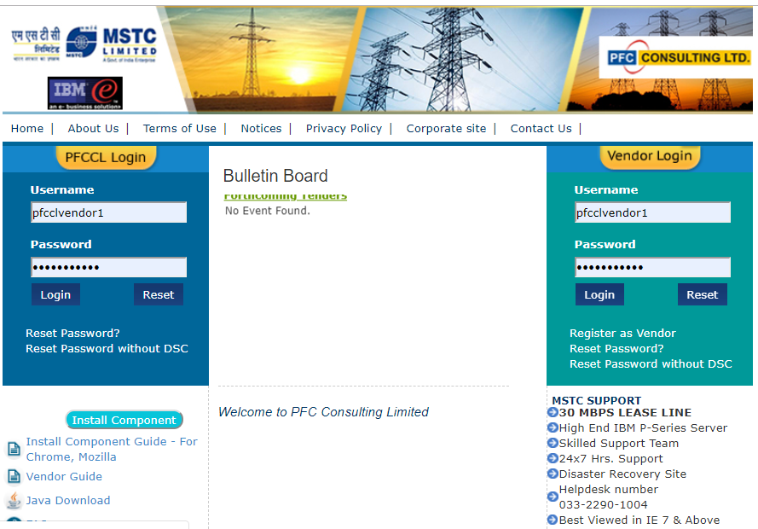
- On the right side of the page click on Register as a Vendor:

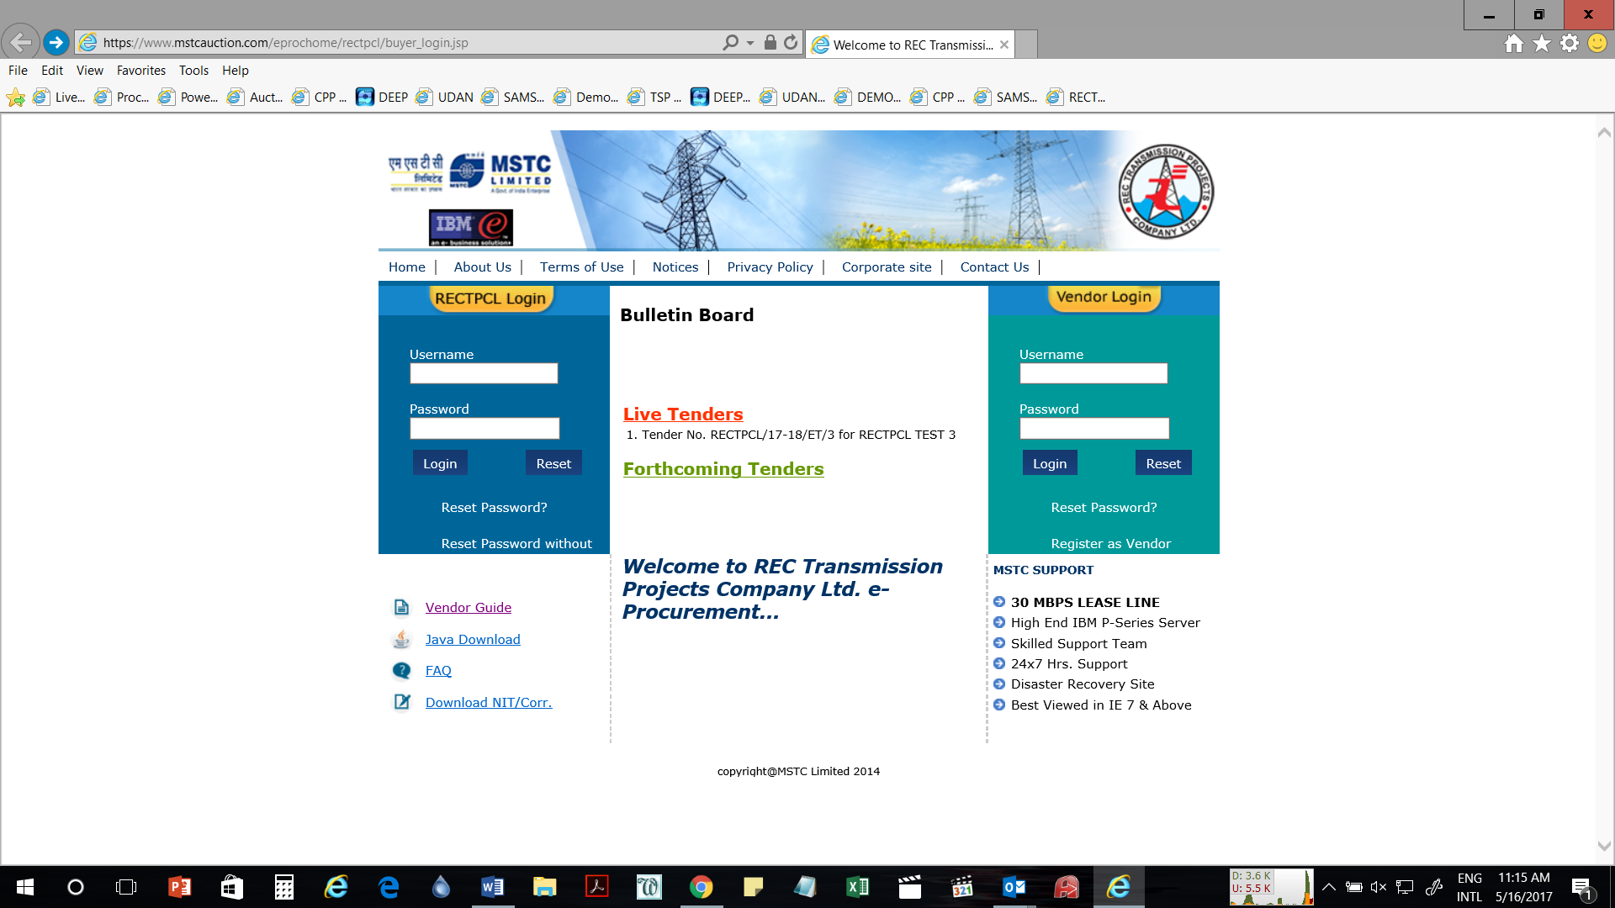
- Fill the form that appears to create username and password.
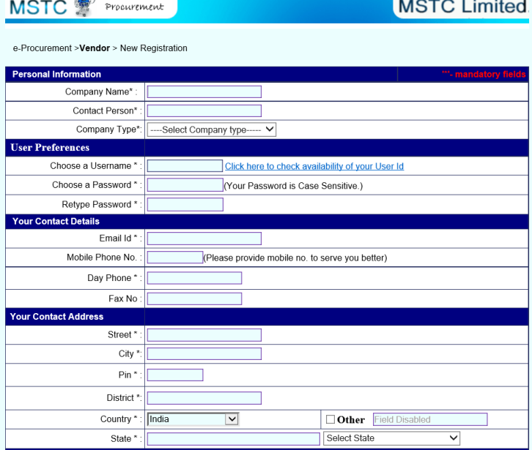
- Once the registration is done, login with your user name and password:
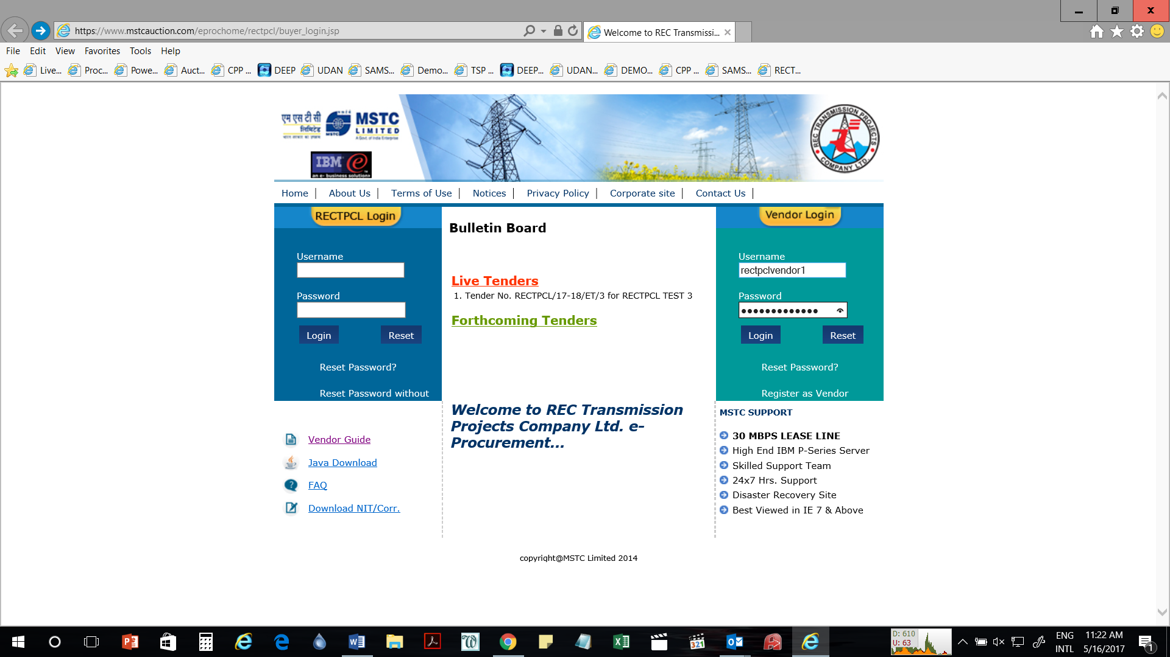
- System will ask you to verify your digital signature
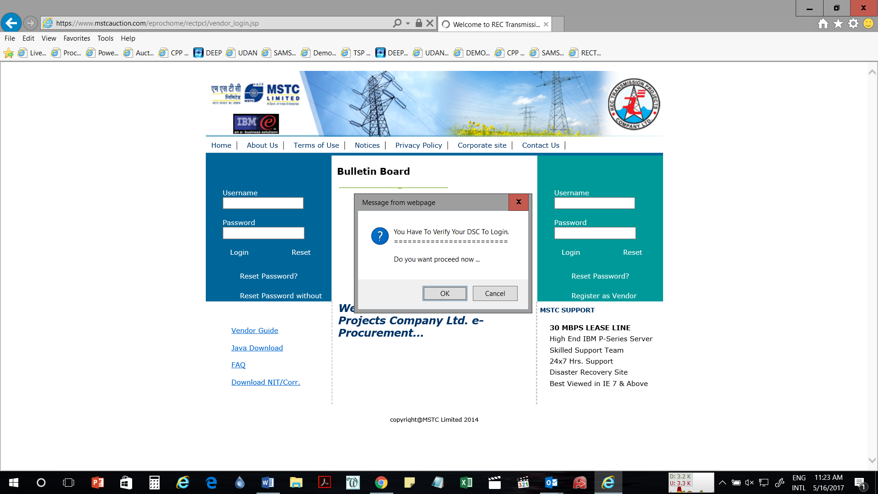
- Press Ok and select your digital signature from the List:
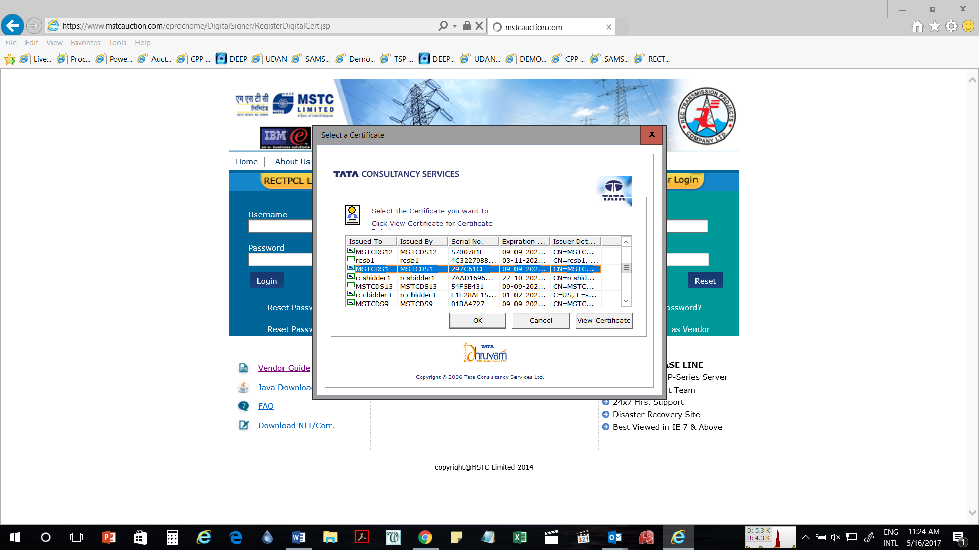
- Your digital signature will be verified
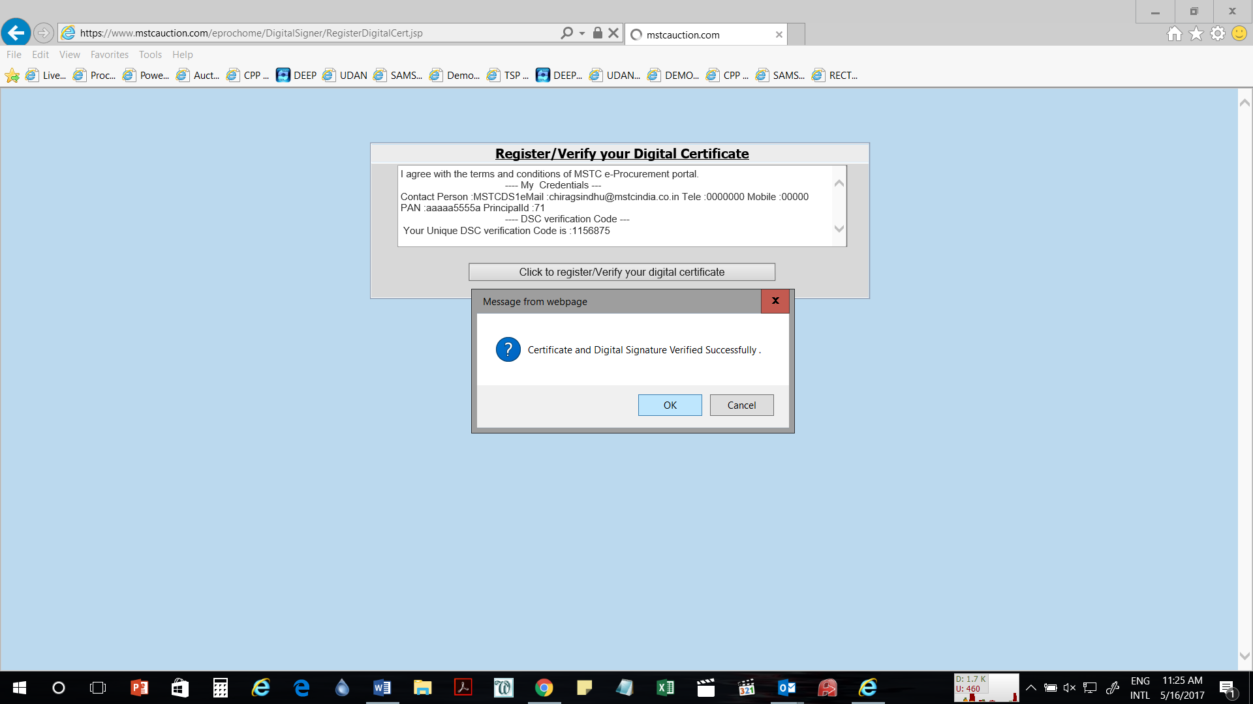
- Once login is complete, a bidder can access My Menu through the left side of the page:
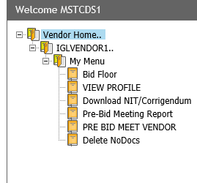
- Here click on Download NIT/Corrigendum button to download the NIT/Corrigendum’s. Select Event number and click on download to download the files:
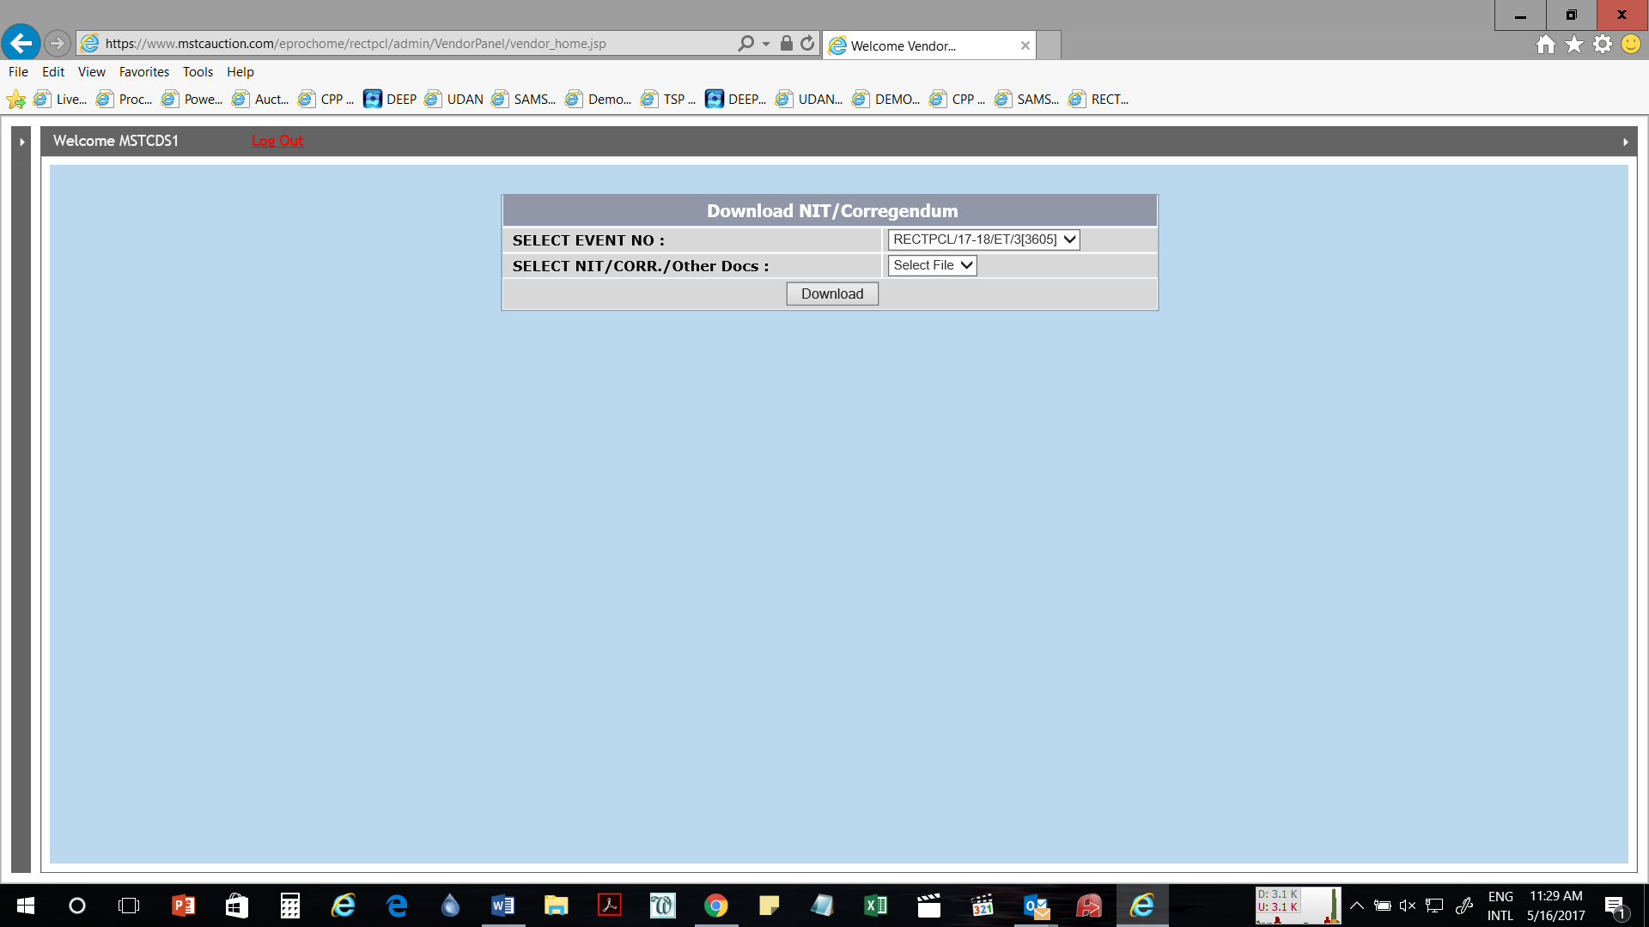
- To submit the bid a bidder can proceed to Bid Floor through the left side My menu. In Bid Floor click on live events to view a list of Live events. In live events select the tender number where you wish to submit a bid.
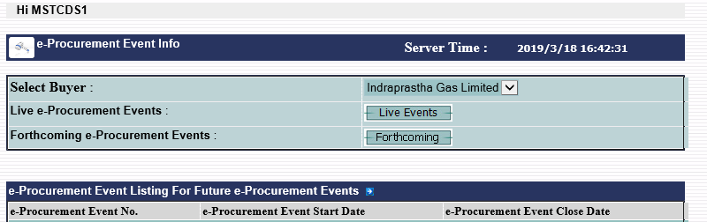
- On clicking the event number, if the bidder has not paid transaction fee, system will prompt them to pay the transaction fee. They can pay the transaction fee by going to Transaction Fee payment link in their login, and pay the same through online payment (debit card, credit card, net banking etc) or RTGS/NEFT (Challan).
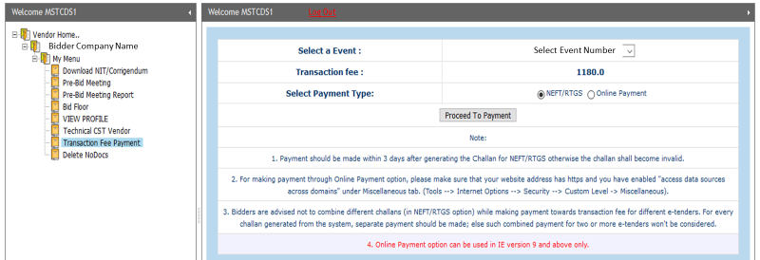
- Tender can be of multiple types with price bid uploading in Excel or Technical-Price type. The bid floor for each type of event will change automatically.
On clicking the tender number one of the following screens will appear:
For 2 cover with price bid in excel

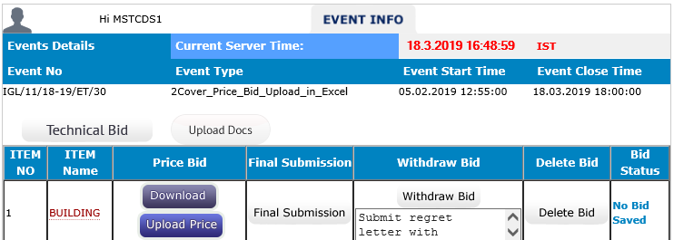
E-Tender Technical cum Price Bid
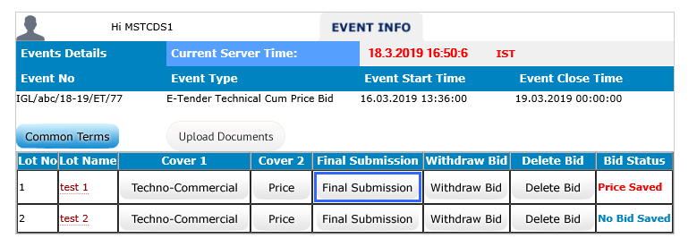
- For each type of event the event details including start time and close time the details will be given on the top of the page.
- To submit the tender the bidder has to start from top left and submit the details one by one.
- For 2 cover with price bid in excel, the bidder has to submit technical bid, by filling the details and clicking the save button.
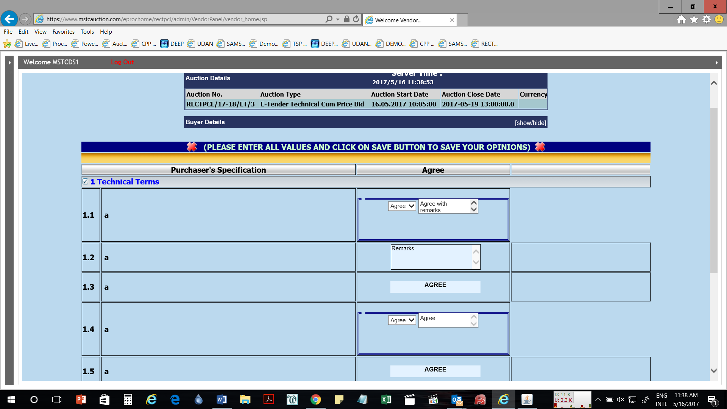
- After the technical bid is saved, a bidder can proceed to uploading documents through the link upload docs:

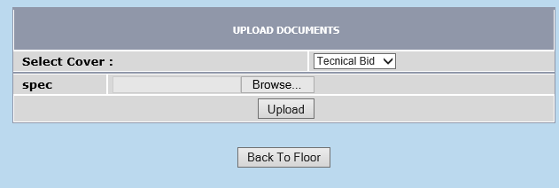
- Please note that under no circumstance the price bid excel has to be uploaded here.
- After the documents have been uploaded, the bidder can click on download excel to download the excel format.
- Fill up the excel sheet as per the details given therein and tender document.
- To upload the filled up excel click on Upload Price Button, click on browse to select the file and then click on Upload and Save encrypt file.

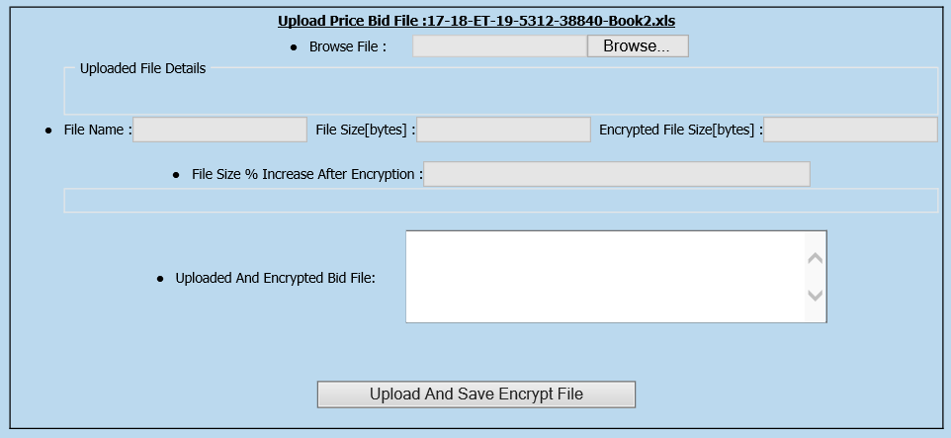
- The bidder can then click on final submit to finally submit the bid. In case of any amendments after final submit, click on delete bid button to delete the techno-commercial and price bids and resubmit the same. Please note that at the end the bid must be final submit, otherwise the same will not be considered.
- For E-Tender Technical Cum Price Bid:
  - In the manner similar to above the bidder has to fill up Common terms, then press save button to submit.
  - Then the bidder has to upload documents as per the list shown therein.
  - Once the documents are uploaded the bidder has to submit the Technical and Price bids.
  - The bidder can then click on final submit to finally submit the bid. In case of any amendments after final submit, click on delete bid button to delete the techno-commercial and price bids and resubmit the same. Please note that at the end the bid must be final submit, otherwise the same will not be considered.
Bidder’s may note that in each case using the Delete bid button will only delete the bids and then the bidder can resubmit upload tender closing time.
Using the withdraw button the bid will be withdrawn and the bidder will not be allowed to submit any further bid in that event.
For any assistance regarding the Tender Document and/or term and conditions the bidders may contact at PFCCL:
Contact Person | Mr. Anubhav Kansal
Telephone | 011-23443910  Email ID – anubhav_kansal@pfcindia.com

For any assistance during bid submission, system settings etc. bidders may contact at MSTC:

Phone Number

MSTC HO Helpdesk team - 03340645207,03340609118,03340645316, 03322831002, 03322891401, 03322891005, 03322901004, 03322895064

MSTC NRO Helpdesk team (Delhi) - 01123212357, 01123215163, 01123217850

Sh. Setu Dutt Sharma, MSTC - 7878055855

Email

mstcnro@mstcindia.co.in ; sdsharma@mstcindia.co.in
Please mention “Helpdesk” as subject while sending emails

